LAB EXPERIMENT
SET 16: CUSTOMER DEMOGRAPHICS ANALYSIS
Department | AIDS
Course Code / Course Name | DSA0602 / Data Handling and Visualization
Experiment | Data Visualization using R and Tableau
Name | D.HEMASREE
Register Number | 192524114
Date | 10 October 2026
Day | Saturday
Aim
To analyze customer demographic data using a bar chart, a pie chart and a demographics table in R, and to build an interactive dashboard using Tableau. Dataset: Customer Demographics
Customer ID | Age | Gender | Income (in $)
1 | 28 | Female | 50000
2 | 35 | Male | 60000
3 | 42 | Female | 75000
PROGRAM 1: Bar Chart of Customer Ages
Create a bar chart to visualize the distribution of customer ages. Label the axes and title the chart.
customers <- data.frame(
Customer_ID = 1:3,
Age = c(28, 35, 42),
Gender = c("Female", "Male", "Female"),
Income = c(50000, 60000, 75000)
)

bp <- barplot(customers$Age,
names.arg = paste("Customer", customers$Customer_ID),
col = "steelblue",
xlab = "Customer ID",
ylab = "Age (years)",
main = "Distribution of Customer Ages",
ylim = c(0, 50))
text(bp, customers$Age, labels = customers$Age, pos = 3)

OUTPUT:
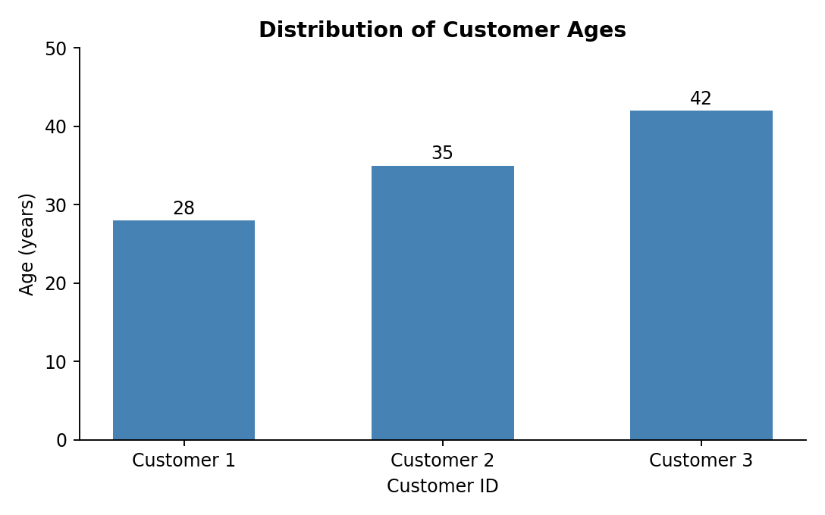
Output 1: Distribution of Customer Ages (Bar Chart)
Observation:
The three customers are aged 28, 35 and 42, spaced evenly seven years apart. Customer 1 is the youngest and Customer 3 the oldest. The average age is 35 and the ages cover a range of 14 years.

PROGRAM 2: Pie Chart of Customers by Gender
Generate a pie chart to represent the distribution of customers by gender.
customers <- data.frame(
Customer_ID = 1:3,
Age = c(28, 35, 42),
Gender = c("Female", "Male", "Female"),
Income = c(50000, 60000, 75000)
)

gender_counts <- table(customers$Gender)
percent <- round(100 * gender_counts / sum(gender_counts), 1)
pie_labels <- paste0(names(gender_counts), " (", percent, "%)")

pie(gender_counts,
labels = pie_labels,
col = c("lightcoral", "steelblue"),
main = "Distribution of Customers by Gender")

OUTPUT:
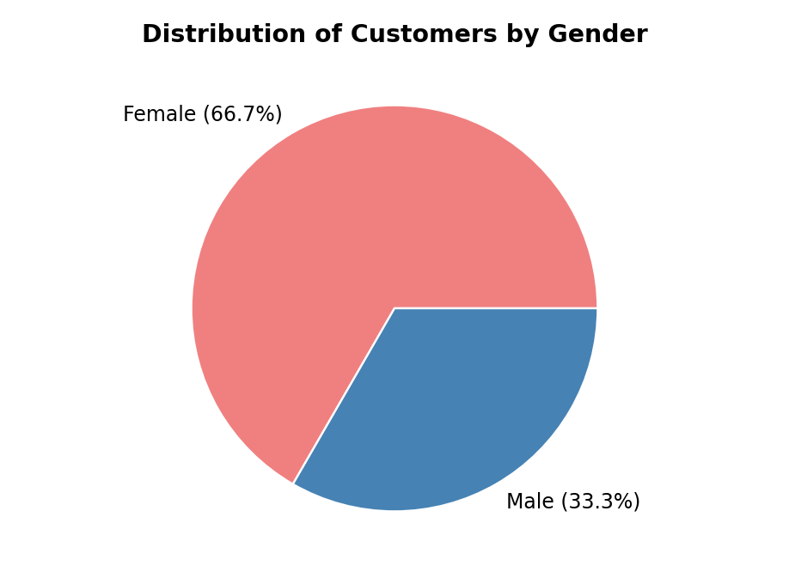
Output 2: Distribution of Customers by Gender (Pie Chart)
Observation:
Female customers make up two thirds of the group (2 customers, 66.7%) and male customers one third (1 customer, 33.3%). The group is therefore weighted towards female customers.

PROGRAM 3: Table of Demographic Information
Build a table to show the demographic information for each customer. Label the table elements.
customers <- data.frame(
Customer_ID = 1:3,
Age = c(28, 35, 42),
Gender = c("Female", "Male", "Female"),
Income = c(50000, 60000, 75000)
)

print(customers)

mean(customers$Age)
mean(customers$Income)
table(customers$Gender)

OUTPUT:
Console Output
Customer_ID Age Gender Income
1 1 28 Female 50000
2 2 35 Male 60000
3 3 42 Female 75000

[1] 35
[1] 61666.67

Female Male
2 1

Output 3a: Customer Demographics Table (R Console)
Customer ID | Age | Gender | Income (in $)
1 | 28 | Female | 50000
2 | 35 | Male | 60000
3 | 42 | Female | 75000
Average | 35 | - | 61666.67
Output 3b: Customer Demographics Table with Averages
Observation:
The table gives the age, gender and income of each customer. The average age is 35 and the average income is about $61,667. Income rises with age: Customer 1 (28) earns $50,000, Customer 2 (35) earns $60,000 and Customer 3 (42) earns $75,000, the highest in the group.

PROGRAM 4: Interactive Customer Demographics Dashboard in Tableau
Develop a Tableau dashboard combining the bar chart, pie chart and the table for interactive exploration of customer demographics.
Steps in Tableau
- Save the data as an Excel or CSV file and connect to it in Tableau (Connect > Microsoft Excel / Text file). Right-click Customer ID and choose Convert to Dimension so that it is not summed.
- Sheet 1 (Bar Chart): Drag Customer ID to Columns and Age to Rows (SUM). Add Age to Label and give the axes and title meaningful names. Rename the sheet "Customer Ages".
- Sheet 2 (Pie Chart): Change the Marks type to Pie. Drag Gender to Color and Number of Records to Angle. Add Number of Records to Label and apply Quick Table Calculation > Percent of Total. Rename the sheet "Gender Split".
- Sheet 3 (Table): Drag Customer ID and Gender to Rows, Measure Names to Columns and Measure Values to Text. Keep only Age and Income in Measure Values. Rename the sheet "Demographics Table".
- Create a new Dashboard (Dashboard > New Dashboard), set the size to Automatic, and drag the three sheets onto the dashboard area.
- Add interactivity: select each chart and click Use as Filter, so clicking a customer or a gender in one view filters the others. Add Gender and Customer ID filters (Show Filter > Apply to Worksheets > All Using This Data Source).
- Add the title "Customer Demographics Dashboard" and test the filters in Presentation Mode.
OUTPUT:
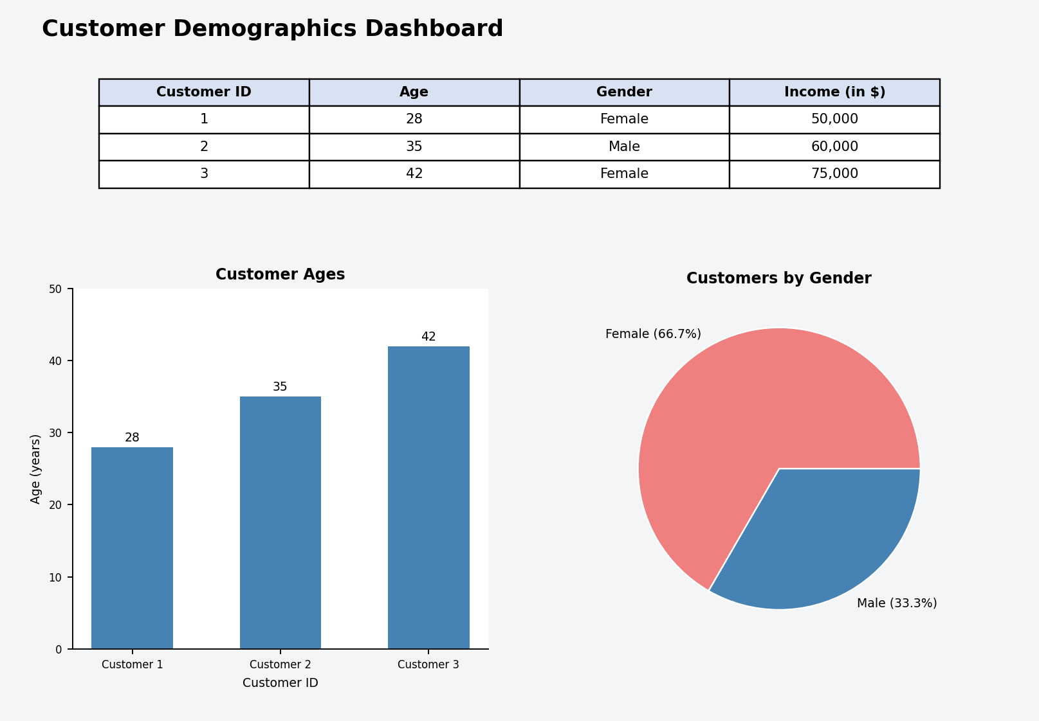
Output 4: Interactive Customer Demographics Dashboard (Tableau)
Observation:
The dashboard shows the customer ages, the gender split and the demographics table together. Selecting a customer or a gender in any view filters the other two.
Procedure
- Define the customer data in R as a data frame with Customer_ID, Age, Gender and Income.
- Use barplot() to create the bar chart of customer ages and label the axes and title.
- Count the customers by gender with table(), calculate the percentages, and draw the pie chart with pie().
- Display the customer data with print() and calculate the average age and income with mean().
- Load the customer file into Tableau and build the bar chart, pie chart and table worksheets.
- Combine the worksheets in a Tableau dashboard and add filters and actions for interactivity.
RESULT:
The customer demographic data was successfully analyzed using a bar chart, a pie chart and a demographics table in R. An interactive Tableau dashboard was also created, combining all three views so that users can explore the customers by age, gender and income.
Key Functions and Tools Used
Function / Tool | Purpose
data.frame() | Creates the customer demographics table.
barplot() | Creates the bar chart of customer ages.
table() / round() | Counts customers by gender and calculates percentages.
pie() | Creates the pie chart of the gender distribution.
print() / mean() | Displays the table and calculates average age and income.
Tableau Pie Mark | Builds the gender pie chart from Gender and Number of Records.
Tableau Dashboard | Combines worksheets with filters and actions.

